What is Anomaly?

In machine learning, an anomaly refers to a data point or pattern that significantly deviates from the expected or normal behavior of the dataset. Anomalies are often called outliers and can indicate errors, fraud, rare events, or system faults.

Anomaly Detection Techniques:
- Statistical Methods: Z-score, IQR, Grubbs' test.
- Machine Learning Methods:
  - Unsupervised: Assumes anomalies are rare and different (e.g., Isolation Forest, DBSCAN).
  - Semi-supervised: Trained on normal data only, flags deviations (e.g., Autoencoders, One-Class SVM).

To visuilzed the broad view of our dataset
# Create a scatter plot of the data. To change the markers to blue "x",
# we used the 'marker' and 'c' parameters
plt.scatter(X_train[:, 0], X_train[:, 1], marker='x', c='b')

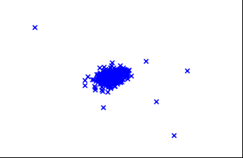

Most commonly used Techniques to detect and handle anomaly :

Isolation Forest: Concept and Working
Isolation Forest (IF) is an anomaly detection algorithm that operates on the principle of isolation. It isolates anomalies by randomly selecting a feature and splitting the data along a randomly chosen value within the range of that feature. It is particularly efficient for high-dimensional data.

Here are the important points about Isolation Forest:

Conceptual Overview
Isolation Principle:
  - Isolation Forest detects anomalies by isolating data points.
  - Anomalies are easier to isolate due to their sparse or distant nature.
Random Splits:
  - It randomly selects a feature and a split value to partition the data.
Path Length:
  - The number of splits required to isolate a point is called the path length.
  - Anomalies have shorter path lengths because they are isolated quickly.
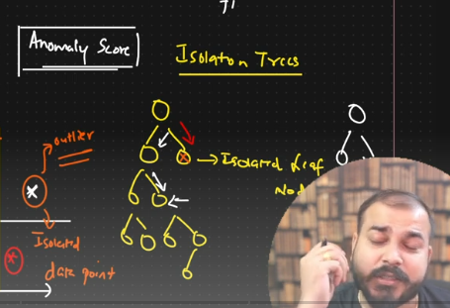

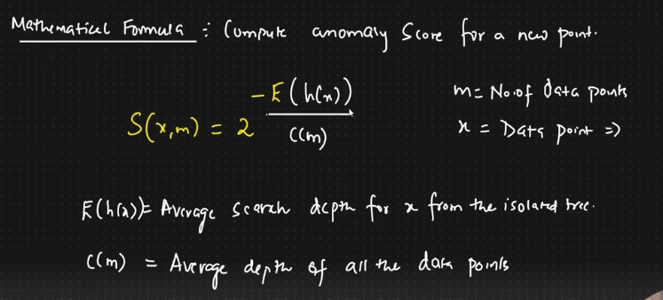

Technical Highlights
Anomaly Scoring:
  - An anomaly score is derived from the average path length of a point across all trees in the forest.
  - Scores closer to 1 indicate anomalies, and scores near 0.5 indicate normal points.

Efficiency:
  - The algorithm has a time complexity of O(nlogn), making it scalable for large datasets.

Unsupervised Learning:
  - Does not require labeled data, making it suitable for unsupervised anomaly detection tasks.

Advantages
- Scalability:
  - Can handle large datasets efficiently.
- Versatility:
  - Works well with both high-dimensional and low-dimensional data.
- Robustness:
  - Handles a mix of continuous and categorical data (after preprocessing).

Use Cases
- Fraud Detection:
  - Detect fraudulent transactions in finance and banking.
- Network Security:
  - Identify intrusions or abnormal behavior in network traffic.
- Manufacturing:
  - Monitor equipment or process health to detect faults.

Implementation Tips

Key Parameters:
  - n_estimators: Number of trees in the forest (default: 100).
  - max_samples: Number of samples per tree (default: auto = min(256, n_samples)).
  - contamination: Proportion of anomalies in the data (helps set threshold).

Choosing the right value for contamination

4. Default Behavior
- If you do not specify contamination, the default behavior is auto:
  - The algorithm tries to estimate the threshold automatically, assuming the dataset is balanced.
  - However, this may not work well if the dataset has a large class imbalance or if there is no clear separation between anomalies and normal points.

5. Choosing the Right Value
- Small Contamination:
  - Use a small value (e.g., 0.01 or 0.05) when you expect very few anomalies (e.g., fraud detection, rare events).
- High Contamination:
  - Use a larger value (e.g., 0.1 or 0.2) when you suspect that anomalies make up a significant portion of your data.
- You can also experiment with different values and inspect the results.

Preprocessing:
  - Standardize the data if features have different scales. Not necessay in isolation forest
Output:
  - predict(): Returns 1 for normal, -1 for anomaly.
  - decision_function(): Provides anomaly scores for ranking.

